
Phases of the Moon
ICT Task 2

Learning Intention:

Success Criteria:

Warm-up:
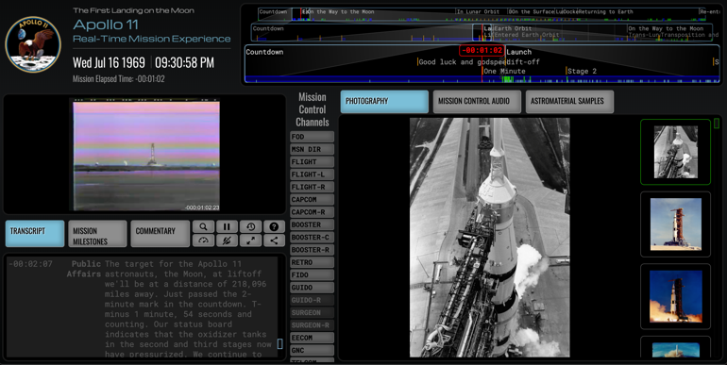
Follow this link: https://apolloinrealtime.org/11/

Explore the Apollo 11 Mission in real time!

Explore the vision captured of Neil Armstrong walking on the moon, the photography of Earth & the radio communication between the lunar module and the NASA control station.

Note: You need to use the scroll bar at the top of the site to skip between milestones and event stages on the mission.

Research: How many missions went to the moon? How many people walked on the moon?

Explore the Lunar Phases

https://sepuplhs.org/middle/third-edition/simulations/moon_phase_simulation.html

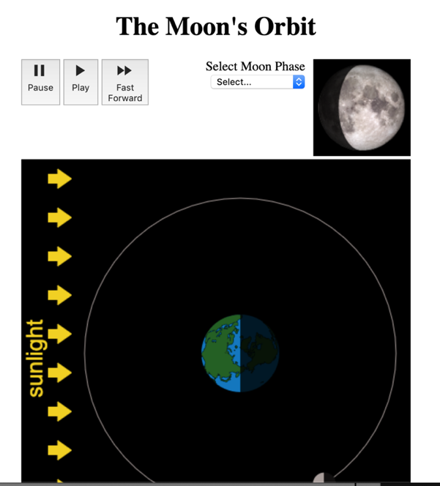

Use this simulation to explore the different phases of the moon’s rotation around the earth.

Pay attention to where the rays of light from the sun hits the earth and the moon.

Look for the different phases of the moon this creates.

Questions

Is there a dark side of the moon Yes/No?

What causes the moon to have the appearance of a changing shape (Phases)?

Provide an explanation as to where does the light on the moon come from?

Activity 3: Create a Moon Phases Slide Show
Use the images below as a guide for what to make.

Utilise the shape drawing tools on Microsoft PowerPoint.
Draw all the phases of the moon and arrange them on one slide.
Label every phase!

For more information on the lunar phases use this link: https://solarsystem.nasa.gov/moons/earths-moon/lunar-phases-and-eclipses/

If you are unsure about how to use the shape drawing tools on Microsoft PowerPoint go to the following link: https://www.lifewire.com/how-to-draw-in-powerpoint-4691715

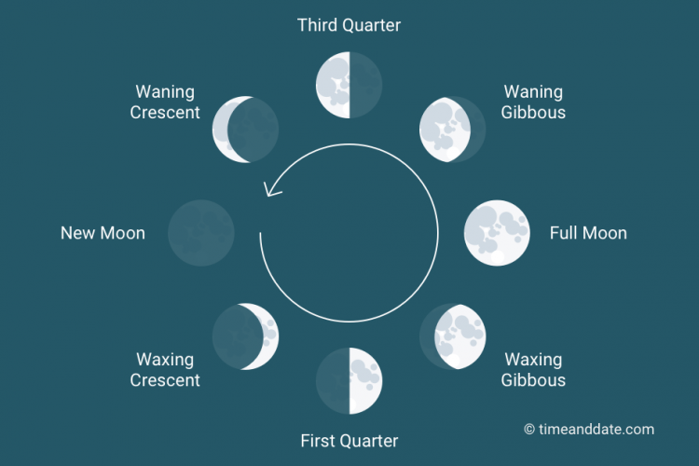
^ this is what you are making


Example shapes drawn in PowerPoint. (Make sure you label the different phases of the moon)

